PROJECT NAME: |  |  |  |  | JOB No.
ATTACHMENT: |  |  |  |  | MR No.
DETAILS
NOZZLE SCHEDULE
Mark | Size, mm | Type | Qty | Function
A | * | * | 1 | VENT
B | * | * | 1 | LEVEL INSTRUMENTATION
C | * | * | 1 | TRUCK FILL CONNECTION
D | * | * | 1 | CALIBRATION COLUMN RETURN
E | * | * | 1 | OVERFLOW
F | * | * | 1 | DRAIN
G | * | * | 1 | OUTLET
H | * | * | 1 | MANHOLE
I & J | * | * | 1 | LEVEL GAUGE CONNECTIONS
NOTES:
- Manhole shall be a minimum of __ mm in diameter and hinged to facilitate removal.
- The drain shall facilitate complete drainage of the tank.
- The tank overflow and valved drain shall be piped to a common flanged terminal point.
- The truck fill connection shall be piped to grade level.
- The vessel orientation is denoted by an "X" in the appropriate box.
A
B
D
G
F
E
H

C
I
J
 |  |  |  |  | VERTICAL
 |  |  |  |  | VERTICAL
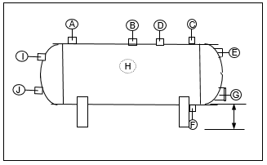
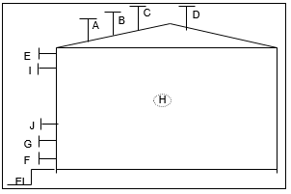
 | FLAT BOTTOM |  |  | HORIZONTAL
 | CHEMICAL |  |  | DESIGN / OPER PRESSURE (barg)
 | SHELL (MTL/THICKNESS) (mm) |  | * | DESIGN / OPER TEMP (°C)
 | HEAD (MTL/THICKNESS) (mm) |  | * | CORROSION ALLOWANCE
 | INSULATION CLIPS / THICKNESS | YES NO |  | FLANGE (RATING / FACING)
 | INSTALLATION LOCATION | Indoors Outdoors |  | FITTINGS RATINGS
 | SUNSHADE | YES NO |  | PIPING AND VALVES - MATERIAL OF CONSTRUCTION (MOC)
 | COATINGS INTERIOR
 | EXTERIOR |  |  | OVERFLOW & DRAIN PIPING - MOC
 | ACCESSORIES | Grounding Lugs |  | WIND LOADING
 |  | Ladder and Platform |  | SEISMIC DESIGN
 | MANUFACTURER | * |  | APPLICABLE CODES/STANDARDS
 | WEIGHT (EMPTY) (kg) | *
 | (OPER / FLOODED) (kg) | * | * | WELDING SPECIFICATION
 | EQUIPMENT TAG NUMBER(S)
 | FLANGE (RATING / FACING) |  |  | OUTSIDE DIAMETER (mm) |  | *
 | QUANTITY |  |  | OVERALL LENGTH/HEIGHT (mm) |  | *
 | P&ID(S) |  |  | USEABLE VOLUME (m³)
NOTES:
- Seller shall replace all * (asterisks) and incomplete check boxes with appropriate information.
- Nozzle and boss locations are schematic only. Final arrangement will be marked on Seller's drawings.

